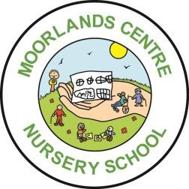
Moorlands Nursery School
Term Dates 2021/22
 | Open on | Close on
Autumn 2021 | Monday 6 September 2021  Open for “Returners” on Tuesday 7 September 2021  Tuesday 2 November 2021 | Friday 22 October 2021  INSET on Thursday 2 September  INSET on Friday 3 September  Friday 17 December 2021  INSET on Monday 1 November
Spring 2022 | Wednesday 5 January 2022  Monday 28 February 2022 | Friday 18 February 2022  INSET on Tuesday 4 January  Friday 8 April 2022
Summer 2022 | Monday 25 April 2022 | Friday 27 May 2022
 | Tuesday 7 June 2022 | Additional day for Queen’s Jubilee on Monday 6 June  Thursday 21 July 2022  INSET on Friday 22 July

School Holiday Dates 2021/22
Autumn half-term 2021 | Monday 25 October  – Friday 29 October 2021
Christmas holiday 2021 | Monday 20 December  – Tuesday 4 January 2022
Spring half-term 2022 | Monday 21 February  – Friday 25 February 2022
Easter holiday 2022 | Monday 11 April  – Friday 22 April 2022
May Bank Holiday 2022 | Monday 2 May 2022
Summer half-term 2022 | Monday 30 May  – Friday 3 June 2022

